Karachi Shipyard & Engineering Works Limited, West Wharf, Karachi, invites tender for the Supply of following on free delivery at KSEW basis:

Tender File | Description | Tender Due Date
LPR-2375  Single Stage Bidding | Card Printer  (As per KS&EW tender specifications) | 23.12.2024
LPR-3825  Single Stage Bidding | Analogue Card  (As per KS&EW tender specifications) | 23.12.2024
LPR-3929  Single Stage Bidding | Welding Cable  (As per KS&EW tender specifications) | 23.12.2024
LPR-3931  Single Stage Bidding | Hydraulic Oil  (As per KS&EW tender specifications) | 23.12.2024
LPR-3934  Single Stage Bidding | Steel Rimer  (As per KS&EW tender specifications) | 23.12.2024
LPR-4103  Single Stage Bidding | Channel  (As per KS&EW tender specifications) | 23.12.2024
LPR-4130  Single Stage Bidding | Ultrasonic Testing Probes  (As per KS&EW tender specifications) | 23.12.2024
LPR-4171  Single Stage Bidding | Radac PB Screen Lead intensifying Screen  (As per KS&EW tender specifications) | 23.12.2024
s

Tender Documents can be downloaded from KS&EW website www.karachishipyard.com.pk and PPRA Website www.ppra.org.pk. However, the supplier/contractor are required to purchase the bidding documents on payment of RS. 2, 000/- from Procurement Department (KSEW) till 22.12.2024 from 08:30 to 16:30 Hrs. Bidders stationed out of Karachi may obtain tender documents through courier service. Tenders will be opened at 11.00 am on tender due date in presence of the bidder’s representatives who may wish to be present. The KSEW reserves the right to accept or reject any or all Tenders in part or whole without assigning any reason as per PPRA Rule 33.

MANAGER (PROCUREMENT)
Karachi Shipyard & Engineering Works Ltd
Phone Numbers: +92-21-99214045-64
Ext: 380/381

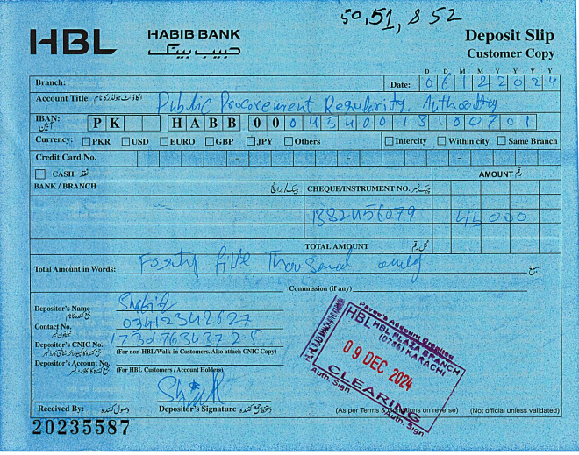
Receipt No | Tender No | Tender Details | Advertised Date | Closing Date | Operations
191066 | LPR -3275 LPR- 3825 LPR- 3929 | LPR -3275 LPR- 3825 LPR- 3929  Tender Description  Details | 6/12/2024 | 23/12/2024  11:00 | Print  Edit  Delete

